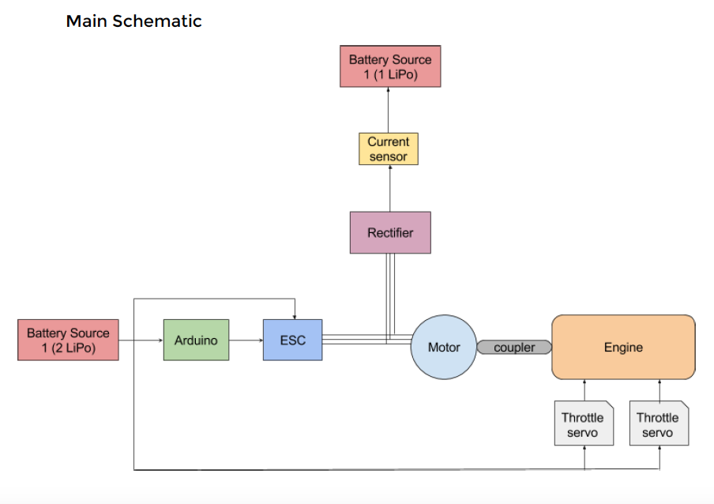

Our schematic diagram only differs in that the load resistance has been connected to the rectifier. However everything else is the same.

This is how all the main components are connected together.

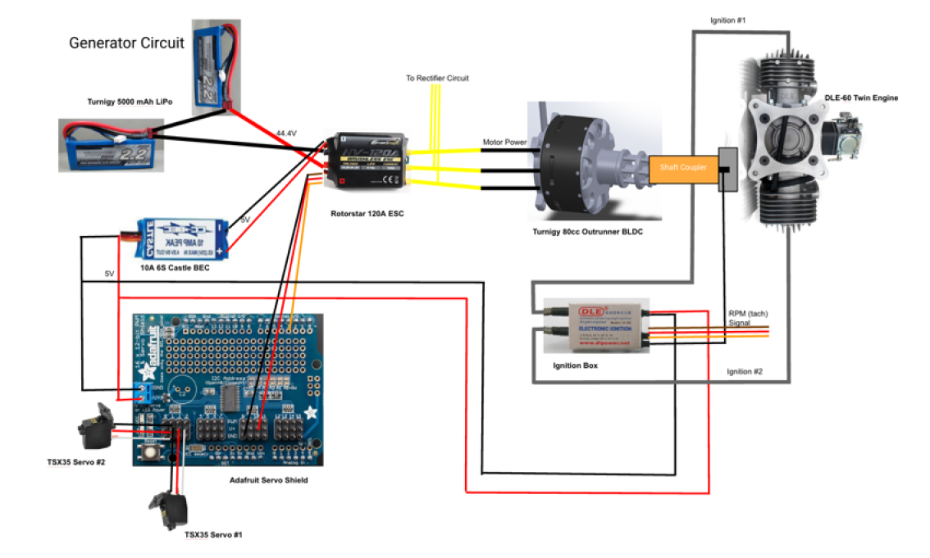

This is the rectifier circuit which now has the load resistance connected to it:

